Fractional Integration Parameter Estimation
- Preliminaries
  - H=d+0.5 (H for Hurst Parameter, d for fractional difference parameter)

- Methods of H Parameter Estimation
  - R/S Plot
    - General Description:
    - Pros:
    - Cons:
  - Modified R/S Plot
  - GPH (Geweke-Porter Hudak)
    - General Description: Semiparametric method that uses regression of periodogram around pole frequency to obtain estimate for Hurst parameter.

    - Pros:
      - Easy to derive asymptotic distribution of estimator relative to heuristic methods.
      - No model assumptions are necessary.
    - Cons:
      - Residuals of regression are assumed highly skewed (exponential RVS), which renders least squares estimation less efficient.
      - High bandwidth bias, especially in small samples sizes. I.e. using a large bandwidth increases bandwidth bias but lowers variance of parameter estimate.
    - Other notes:
      - Robinson (1991) has conditions for applying minimum-variance bandwidth (m) selections to the GPH-Robinson estimator for a non-Gaussian process.
      - Aysmptotic standard error (a.s.e.) α n^{(-1/2)}, and (for large samples) the asymptotic distribution of d is approximated by 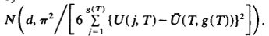, where represents the sum of squared regression errors in the periodogram.
      - Since we’re working with small samples (n=134), we have included a simulation study to get more appropriate standard errors for this parameter estimate.
      - Choice of bandwidth comes from the following:
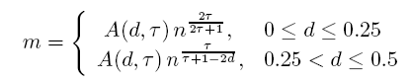, where A(d, Т) = 1, Т
  - Sperio
    - General Description: Similar to GPH, but uses a smoothed periodogram function to obtain estimates for Hurst parameter.

    - Pros:
      - All the pros of GPH method.
      - Use of smoothed periodogram results in smaller bias and variance compared to GPH.
    - Cons:
      - All the cons of GPH method.
    - Other notes:
      - Standard error for the d parameter estimate can be approximated using the following: 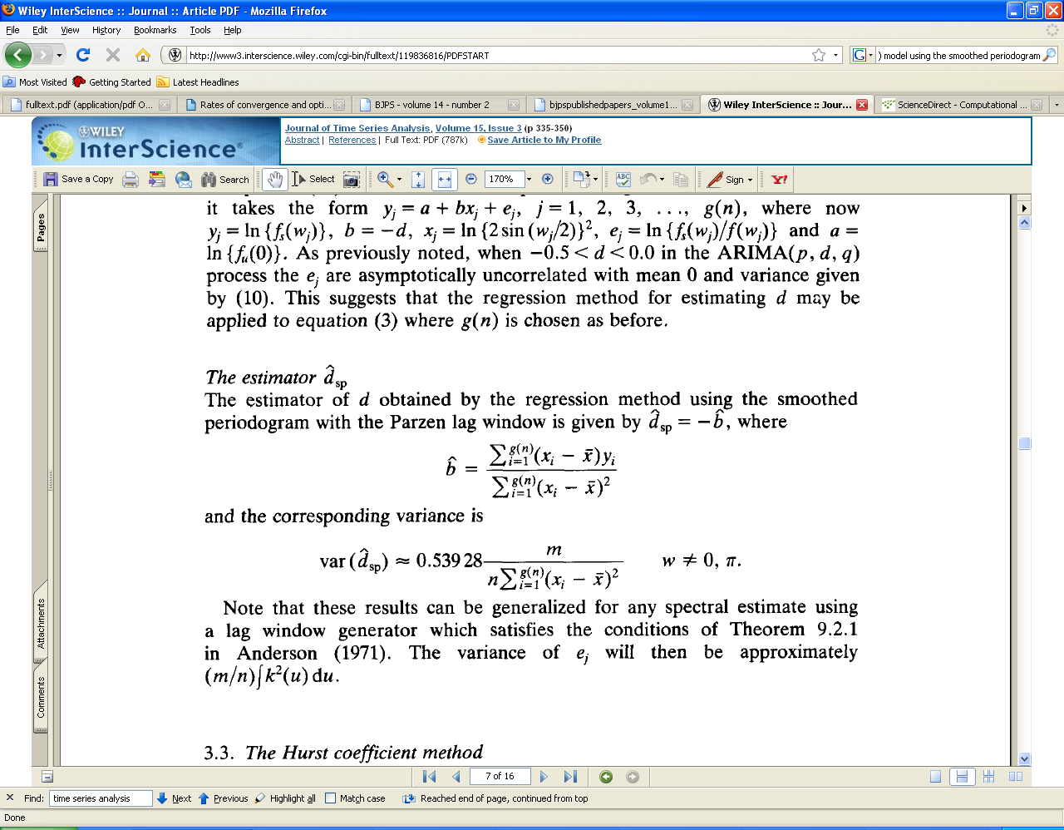, where m is the bandwidth, and is the sum of squared regression errors (as in GPH).
  - Whittle
    - General Description: Uses a Gaussian MLE function to efficiently estimate d.

    - Pros:
      - All the pros of GPH method.
      - Use of smoothed periodogram results in smaller bias and variance compared to GPH.
    - Cons:
      - All the cons of GPH method.
    - Other notes:
      - Standard error for the d parameter estimate can be approximated using the following: , where m is the bandwidth, and is the sum of squared regression errors (as in GPH).

Robinson, P.M. (1991f) Rates of convergence and optimal bandwidth in spectral analysis of processes with long-range dependence.
Geweke, Porter, and Hudak. Application and Estimation of Long Memory Time Series Models (Lindberg-Levy CLT).
Riesen, V.A. (1994). Estimation of the Fractional Difference Parameter.
Riesen, V.A. (1994). Estimation of the Fractional Difference Parameter.

